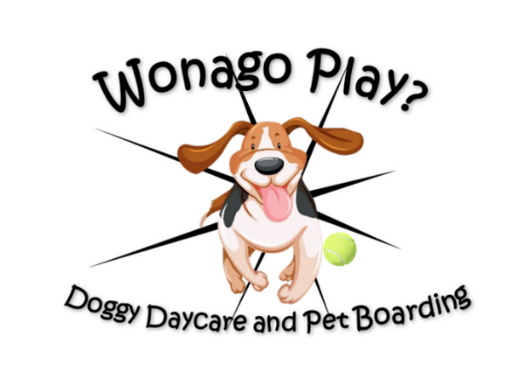
Welcome to Wonago Play?
Doggy Daycare and Pet Boarding
We want thank you for your decision to seek more information on ways to meet your pets’ socialization needs. Our goal is to provide quality daycare and boarding in a safe, fun, and loving environment.
What sets us apart from other daycare centers?
- All our daycare staff have received formal training in socialization and best practices for playgroups.
- Playgroups are determined by size, age, and personality of the dogs.
- We limit our groups to 10 dogs per team member, and dogs are always supervised.
- Dogs are able to play in indoor and outdoor play areas with quality, safe playground equipment.
- Since Wonago Play? Doggy Daycare and Pet Boarding is part of Mukwonago Animal Hospital, pets can have veterinary services provided while onsite, or immediate attention in case of injury.
- Our dogs “play naked” with no collars to prevent injuries from exuberant play
Please contact us ahead of time at to ensure that there is enough space for your dog to play!
262-363-4557 || wonagoplaydoggydaycare@gmail.com || Facebook
Drop-offs
Specified drop-off times ensure that all dogs are safely integrated into playgroups. All dogs are put in kennels until drop-off time is over so that everyone can safely enter the play yard together.
We utilize a rotating nap time system, with three nap groups. Dogs will be in nap time for an hour and a half sometime between 10:00 AM and 2:30 PM depending on when they arrive to play.
7:00 – 9:00 AM
• Morning drop-offs for dogs coming for a full day or for an AM half day. Dogs are put in kennels until play time starts. Our first group goes out at 8:00 AM, our other groups go out at 9:00 AM.
11:30 – 1:00 PM
• PM drop-offs for dogs coming for a PM half day
• Pick-ups for AM half day dogs

4:00 – 6:00 PM
• Pick-ups for full day dogs and PM half day dogs

Rates and Packages: 1 dog 2 dogs
- Full day $35.00 $67.00
- 5 full day package $173.00 $325.00
- 10 full day package $336.00 $630.00
- 20 full day package $651.00 $1,218.00

- Half Day $25.00 $48.00
- 5 half day package $123.00 $236.00
- 10 half day package $241.00 $462.00
- 20 half day package $472.00 $903.00

